**Using S3 bucket for ReactJs static application**

**Create an S3 bucket and deploy the reactjs static application on it and provide with public url for use.**

**S3 bucket:**

**S3** bucket is a object-level storage service that allows to store and retrieve unlimited amount of data at any scale. Data is stored as objects,objects are stored in buckets. Single object can store upto 5 TB of data. By default, data in **S3** is stored redundantly across multiple facilities. A bucket can hold tirllions of objects and millions of requests per second.

S3 is used for storage of static website content like HTML,CSS,JS and other files. These is mostly used due to availabiliy,backup and storage and also supports cross region replication.

We can also encrypt the data in transit and at rest by enabling the server-side encryption. We can configure a trigger to Lambda function to perform some operations when an object is uploaded into bucket.

S3 provides different object level storage classes:

* **Amazon S3 Standard**
* **Amazon S3 Intelligent-tiering**
* **Amazon S3 Standard – Infrequent Access**
* **Amazon S3 Onezone – Infrequent Access**
* **Amazon S3 Glacier**
* **Amazon S3 Glacier Deep Archive**

Depending upon the requirements, we can choose the storage class .

**Hosting a reactjs static application from s3 bucket:**

1. Go to the aws management console,search for s3.
2. Click on create bucket and name the bucket(it should be globally unique).
3. Choose a aws region where you want to launch the bucket.
4. Leave the default settings,and click on create on bucket.
5. Select the bucket, under the properties edit the block all public access to access the bucket using public address.
6. Add a bucket policy to allow the access to the bucket.
7. If you don’t know how to write a bucket policy,we can use policy generator which will create a policy based on the requirements specified.
8. Now go to the permissions.
9. To host a static webiste,we need to enable the static webhosting.
10. Mention the index.html for index page in static webhosting settings.
11. Now, upload the files and folders into the bucket.
12. Upload files and folders seperately by selecting the add files and add folders.
13. These files and folders are uploaded as object.
14. Now, use the url provided for the static webhosting to access the website.

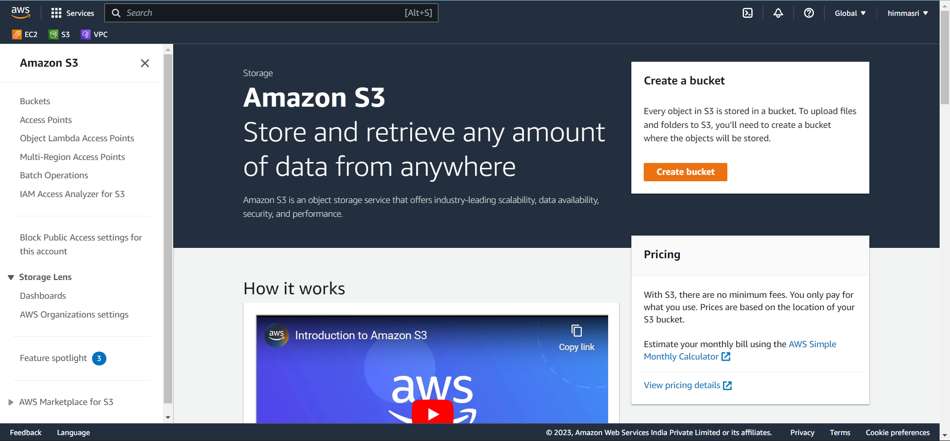hk

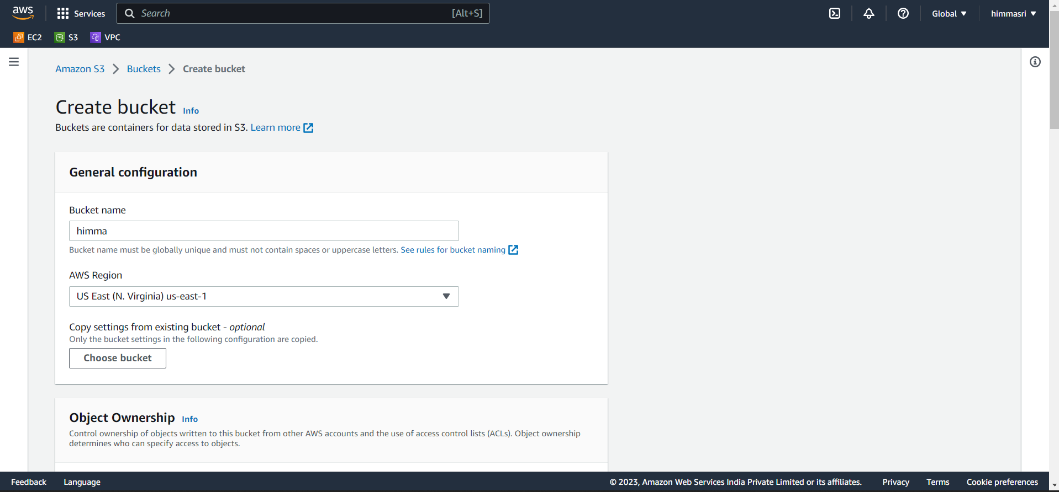

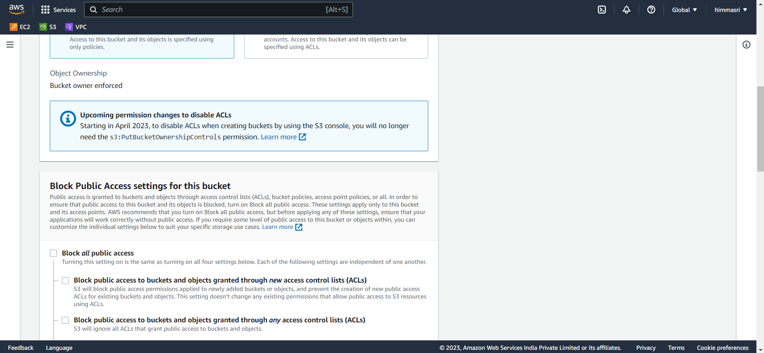

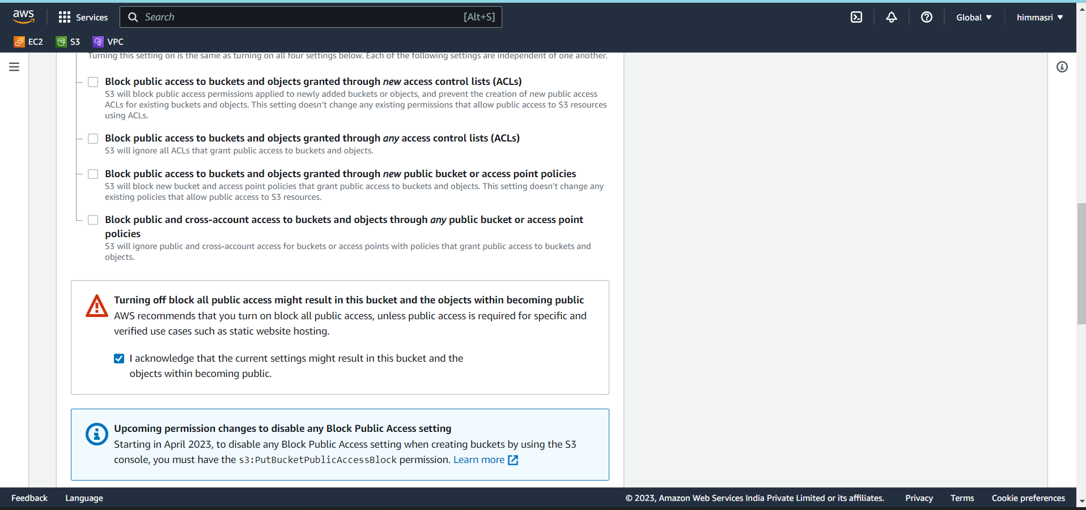

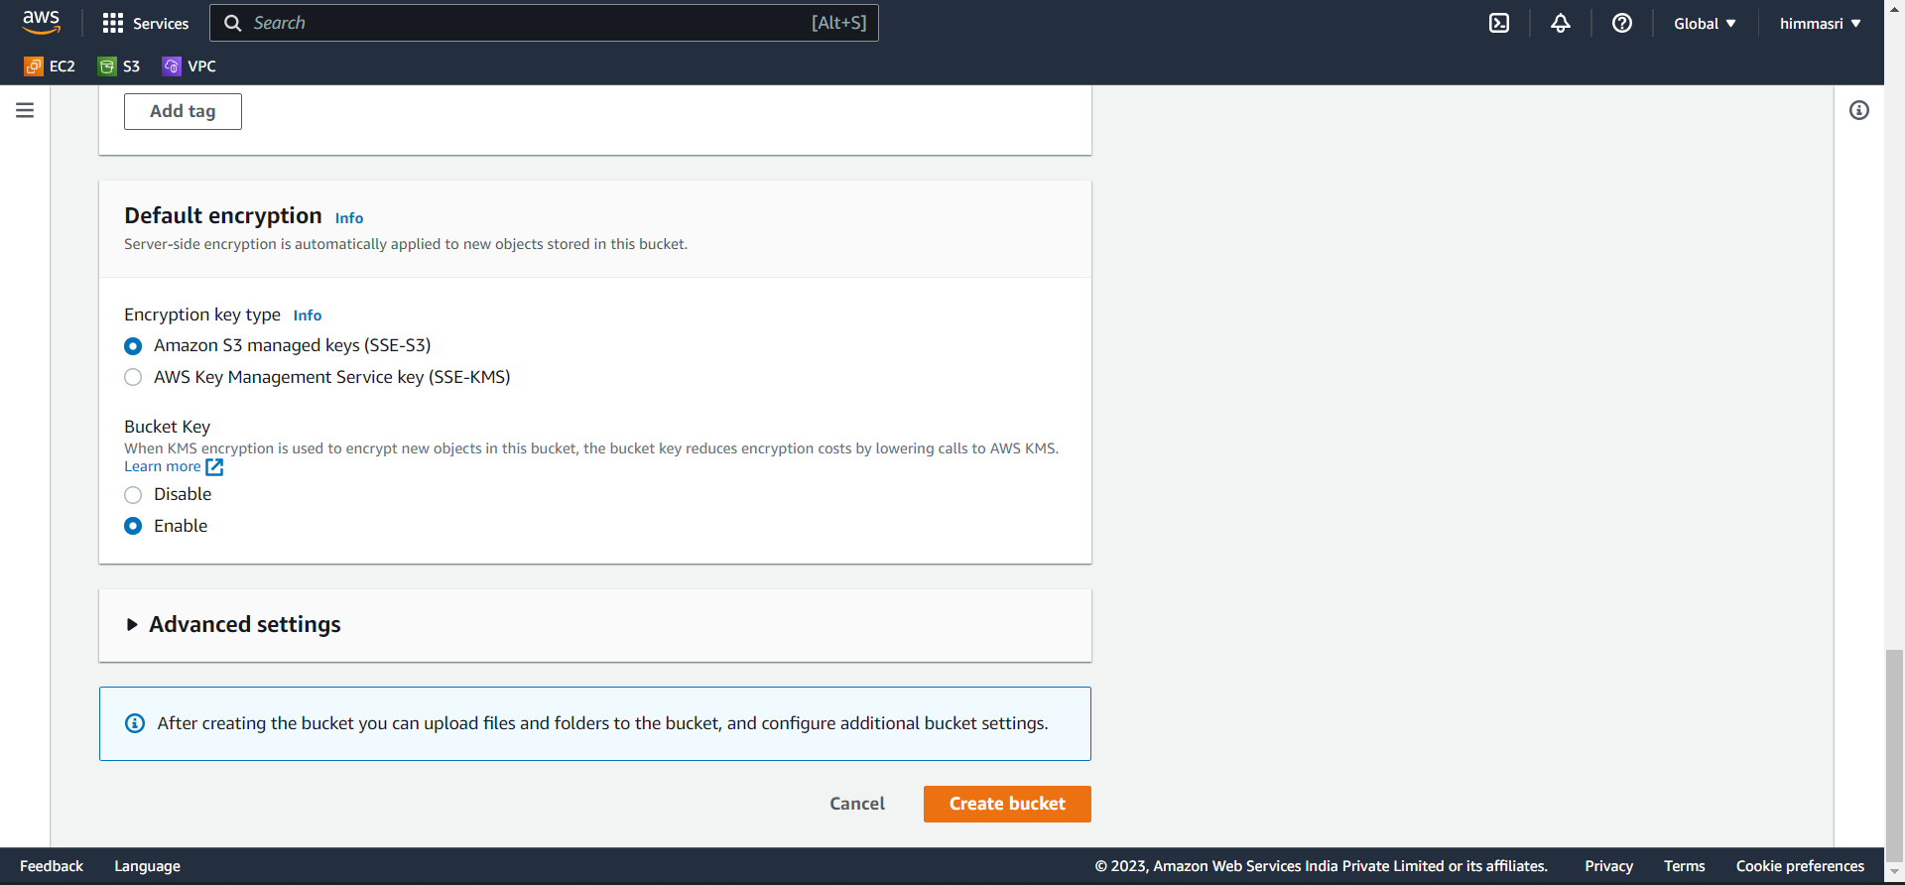

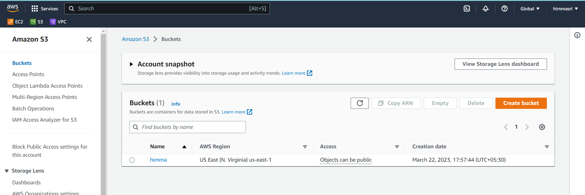

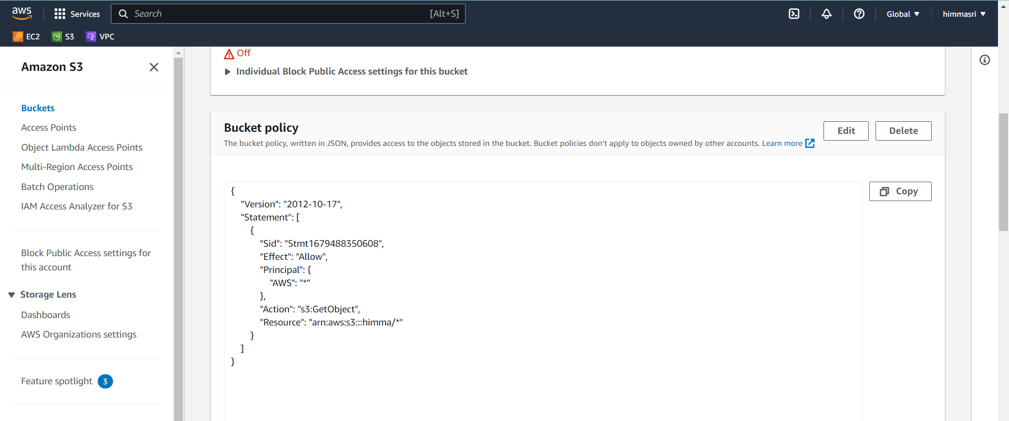

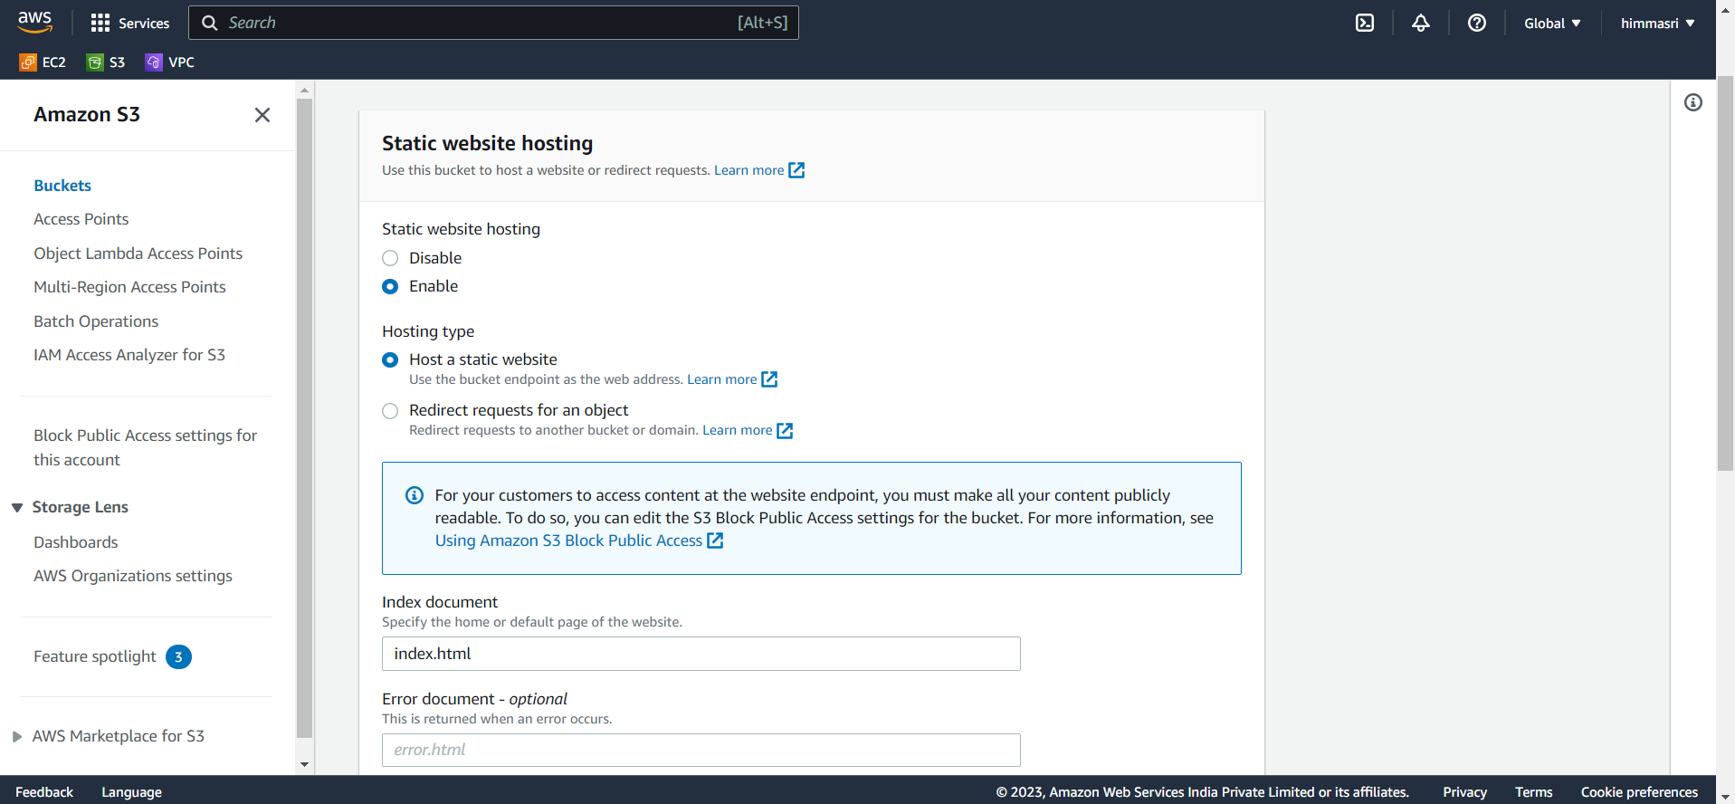

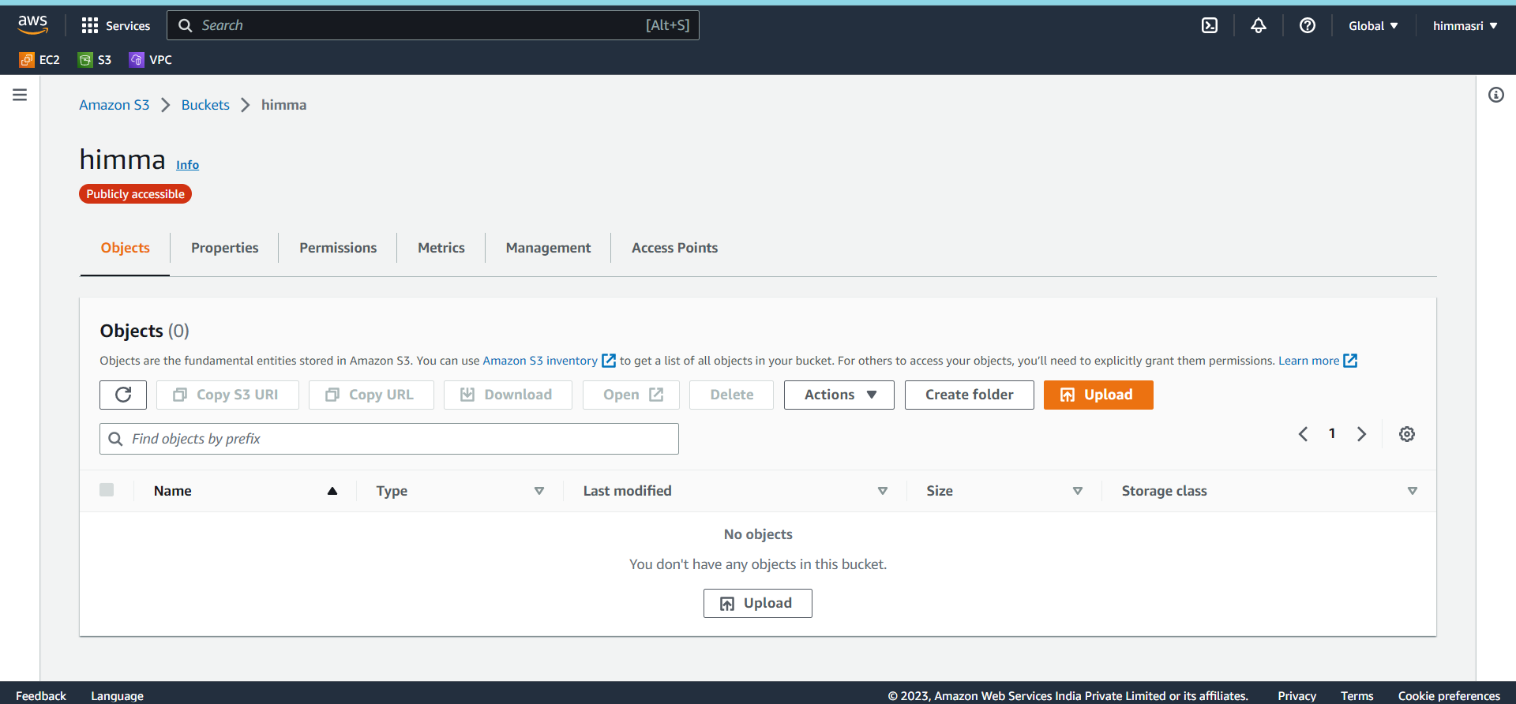

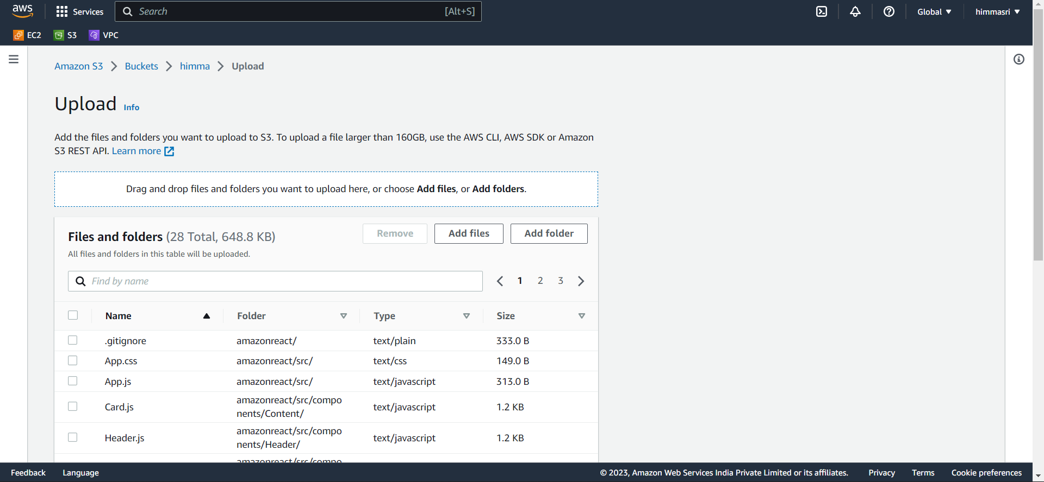

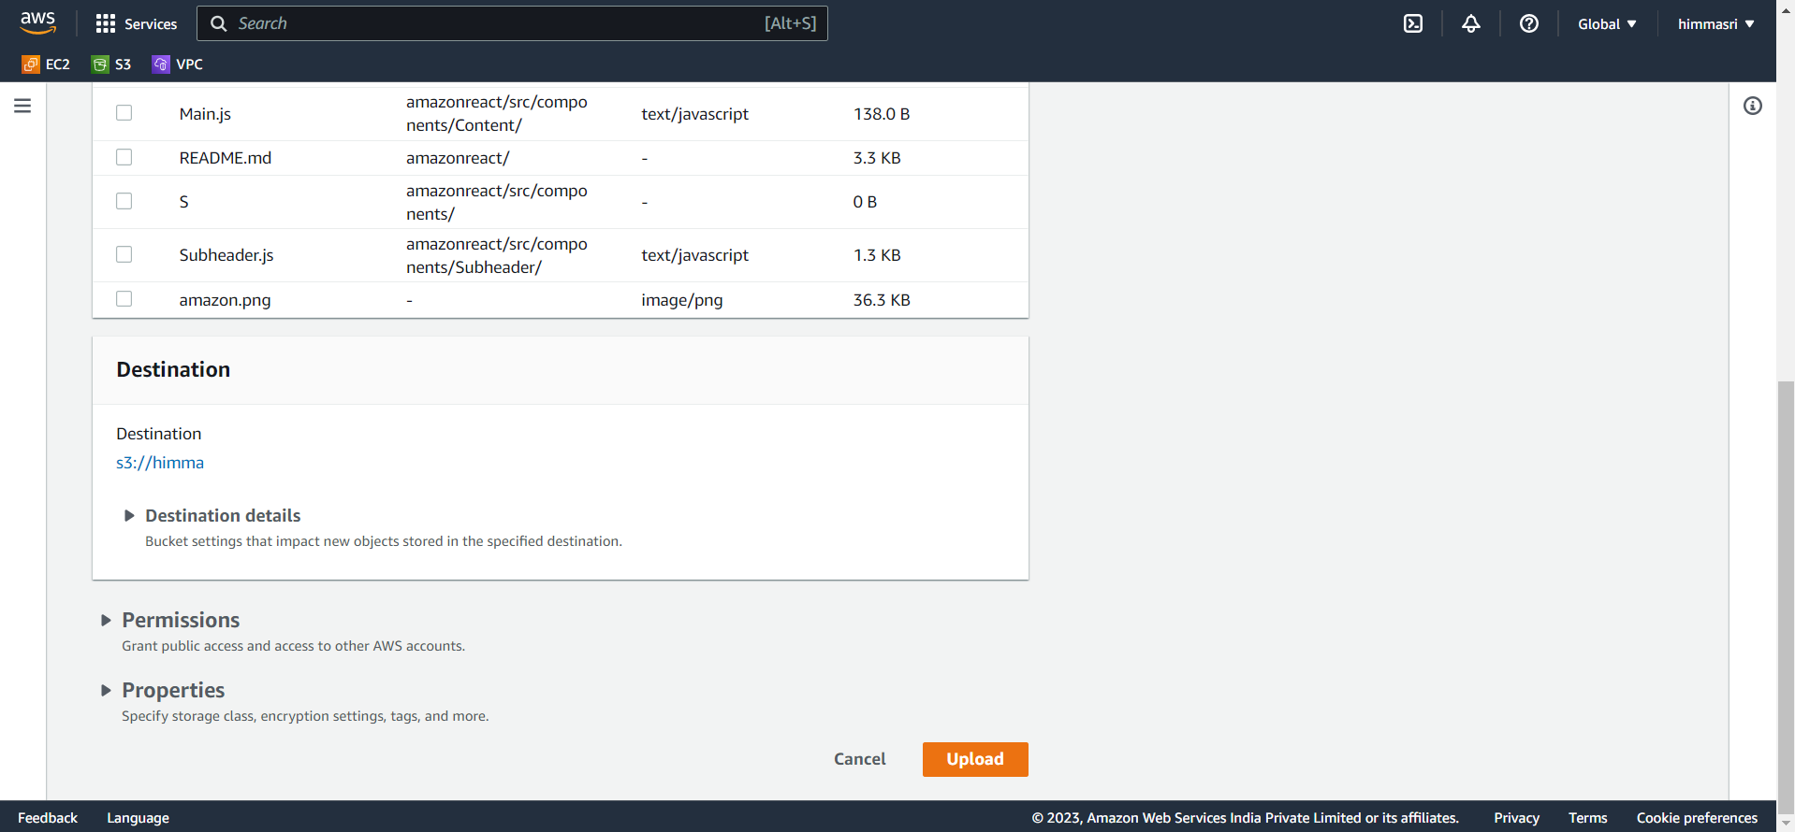

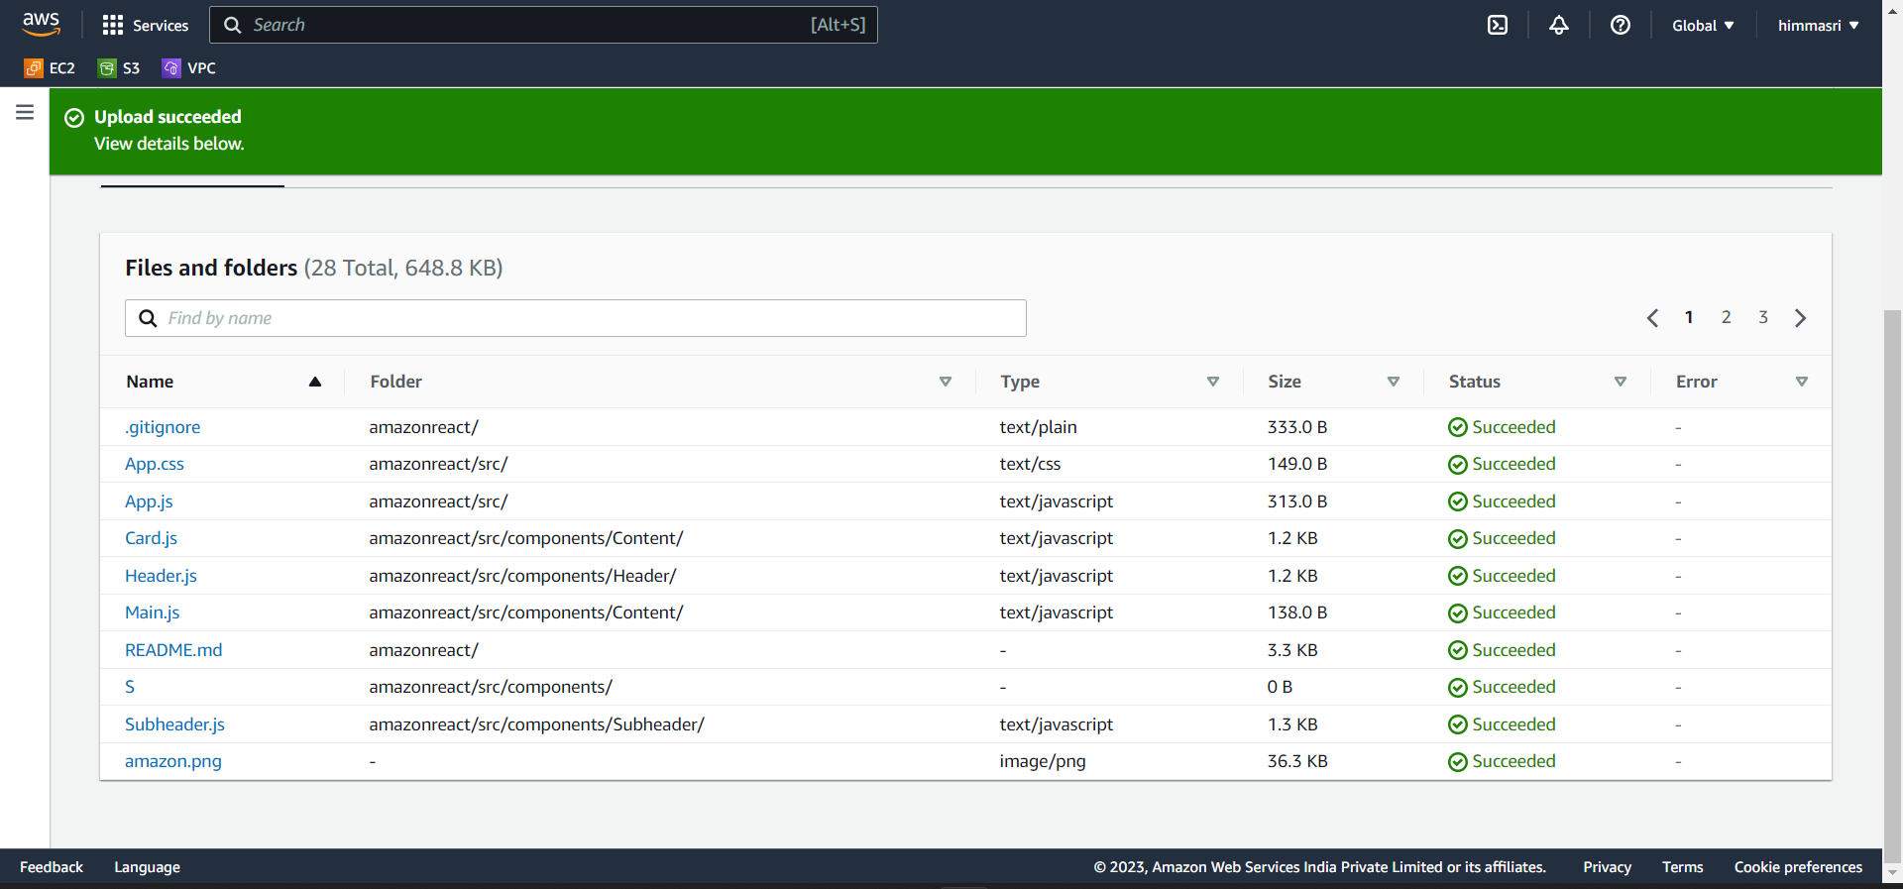

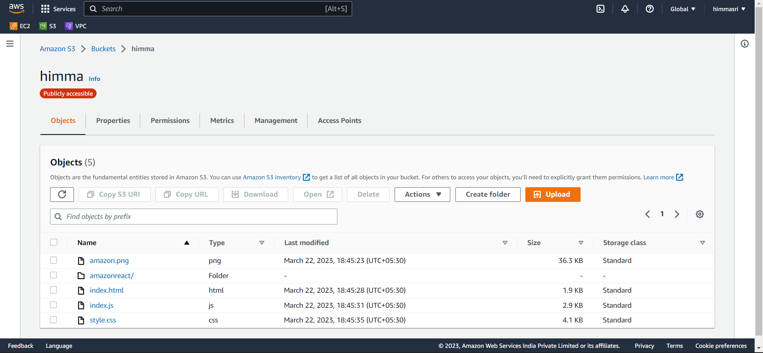

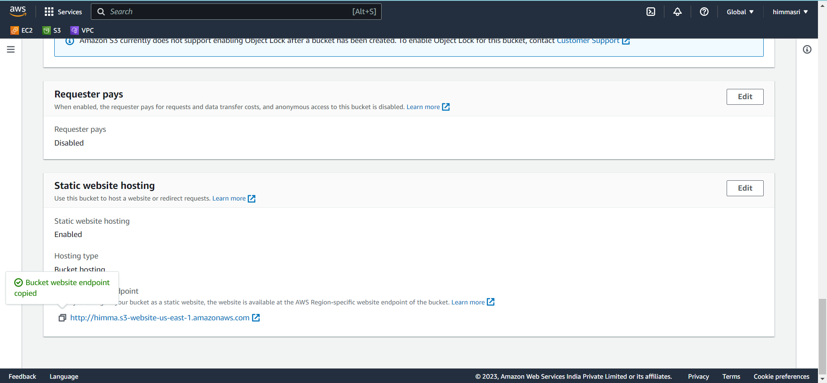

Public URL: http://himma.s3-website-us-east-1.amazonaws.com

